**ACG Assignment External Documentation**

**Prerequisites:**

* Python Libraries:
  + bcrypt library – **pip install bcrypt**
  + socket library – Part of Python Standard Library
  + hashlib library – Part of Python Standard Library
  + PyCryptodome library – **pip install pycryptodomex**
  + hmac library – Part of Python Standard Library
  + pickle library – Part of Python Standard Library
  + PySide6 library – **pip install PySide6**

**Sample Runs:**

 🡨 Wireshark packets and proof of encryption

Starting the server with a password:

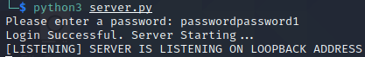

Server key exchanges with client:

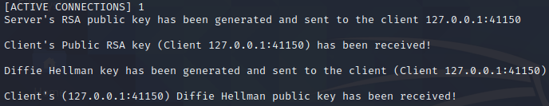

Server sending menu:



Server verification of **day_end** payload:



Server viewing of encrypted files:

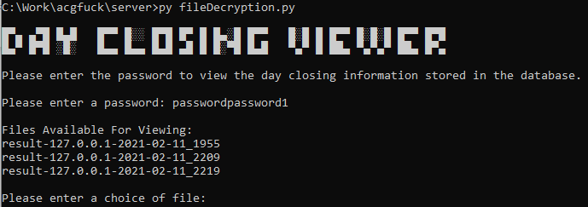

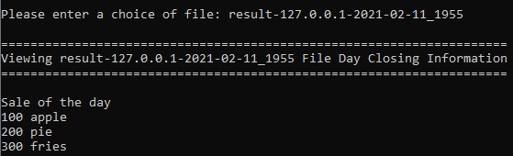

Client key exchanges with server:



Client Graphical User Interface (GUI):

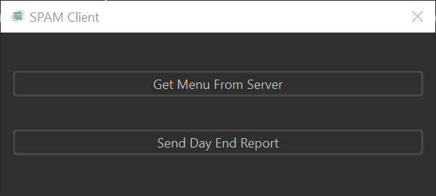

Client requesting menu from server:

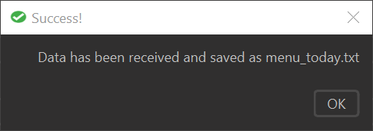



Client verification of menu payload:



Client viewing **menu_today.txt**:

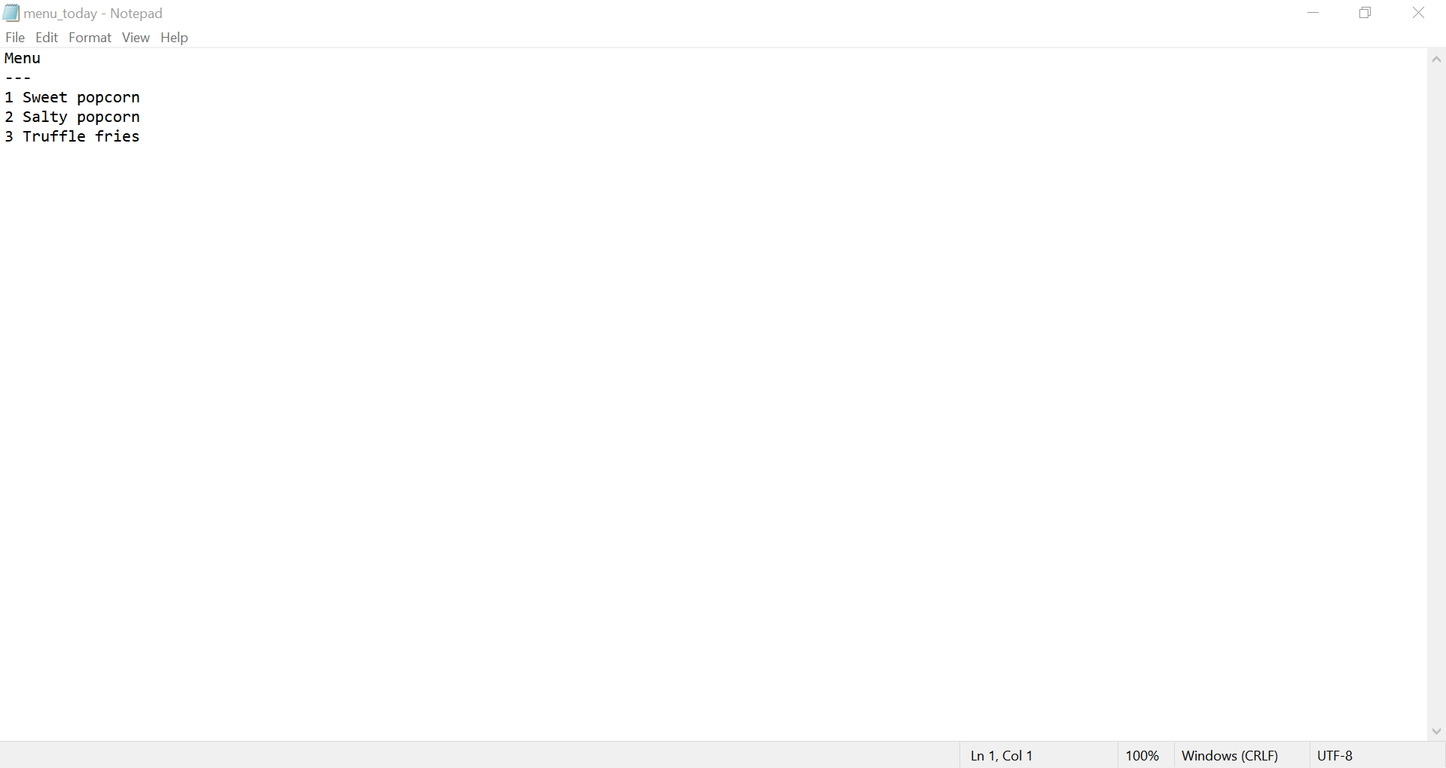

Client sending **day_end** playload to server:

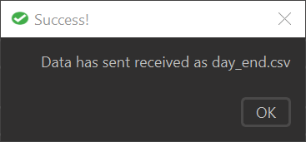

Client verification of **day_end** payload:

